**Preparing to Perform**

# How to support your child with their KS2 tests



**Commissioned by The PiXL Club Ltd.**

This resource is strictly for the use of member schools for as long as they remain members of The PiXL Club. It may not be copied, sold nor transferred to a third party or used by the school after membership ceases. Until such time it may be freely used within the member school.

All opinions and contributions are those of the authors. The contents of this resource are not connected with nor endorsed by any other company, organisation or institution.

©Copyright The PiXL Club Limited

Dear Parents and Carers,

As you know, the Year 6 Key Stage 2 tests (commonly known as SATs) take place in May. Whilst we are working hard at school to prepare your child for these assessments, we value any support that you can give them.

In this booklet we have outlined some of the things which you can do at home, or whilst out and about, to help to prepare your child. Helping them to improve knowledge and skills is important but just as key are the personal things like encouragement, as well as making sure they get enough sleep!

We hope you find this helpful. Please contact us if you have any questions or you would like any further ideas on how to prepare your child for these tests.

Many thanks for your support!

The Year 6 Team

[](https://www.google.co.uk/url?sa=i&rct=j&q=&esrc=s&source=images&cd=&cad=rja&uact=8&ved=2ahUKEwjb0-vNssjZAhVQr6QKHTjsBbYQjRx6BAgAEAY&url=http://fcgagric.com/working-together/&psig=AOvVaw0Uw1X_5an7EBpDIESnFE2d&ust=1519899832177651)

Use the receipt from your **shopping** to ask questions e.g. what is the total of the fruit and vegetables? What change would I get from £50? While unpacking the shopping, guess the weight of items then weigh them. What is the difference in weights?

Try to help your child to improve their **reading speed** by reading an extract from a suitably challenging text. Time them. Repeat. Can they beat their time? Ask a couple of questions about the extract to check their understanding.

Play games to develop their **vocabulary and spelling**. Try games like: Scrabble, Boggle, Pictionary and Taboo. What does the word mean? Can they spell it? Can they use it in a sentence?

Maths

English

At Home



Use **Times Table Rockstars** to practise times tables daily. Can your child recall their facts instantly? Compete against themselves or others to improve their speed!

**Hunt for** … give your child timed challenges when reading. For example, how many adverbs/adjectives can you find in 2 minutes?

**Newspaper maths** – use league tables or weather charts to ask questions e.g. what is the difference between the temperature in London and Moscow? What is the mean (average) of the points scored in the Premier League?

English

Maths

Listen to the lyrics of songs on the **radio**. Can they identify the adjectives? Can they give a synonym (a word with a similar meaning) or antonym (opposite meaning)for one of the words?

**Number plates** – look at the numbers on number plates and create questions based on them e.g. subtract the number from 1000 or multiply/divide the number by 10/100 or 1000.

On the Move

Look at objects and placesthey pass while travelling. Pick out a word and play **‘Just a Minute**’– explain what the object is without using the word itself and without hesitating or repeating themselves.

**Sequences**. Choose a starting number and a rule. Take it in turns to say the next number in the sequence e.g. start with 19 and add/subtract 8. How far can you take the sequence before an error is made? Try decimals too.



**Telling a story**. Give the first line of a story and take it in turns to continue it. Begin each sentence with a conjunction e.g. next, after that, some time later, finally …

**Odd one out**. Give your child four numbers and ask them which is the odd one out and why e.g. 12, 19,18 and 21. 19 is the odd one out because it is the only prime number.

English

Maths

When visiting somewhere, challenge your child to come up with **‘Pointless’ adjectives**. In other words, an adjective that no-one else would think of e.g. a *monumental* tree, a *formidable* skate boarding slope.

**How long**? Select a starting and finishing point in the place. Estimate how many seconds/minutes it would take to walk the distance, then time it. What is the difference between the two times? Who was the closest?

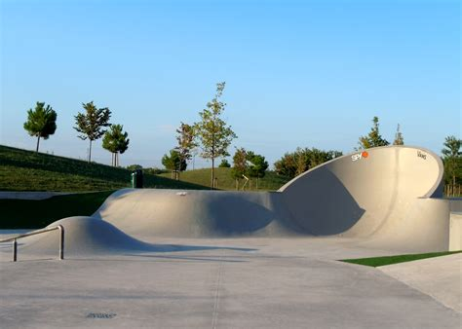Out and About

**I-spy.** Play the game by describing the properties of a shape which can be seen e.g. I-spy a quadrilateral with only one pair of parallel lines *(a trapezium).*

Practise standard English by using the **‘posh voice’**. Pretend you are a visitors’ guide and explain the key highlights of the place using correct standard English.

**How much?** Use entrance fees or a menu to create questions. How much would it cost for 2 adults and 2 children? What would be the change from £50?

Select an object at the place and take it in turns to see how many **antonyms** or **synonyms** you can think of for the word e.g. an antonym of steep is *gentle*; a synonym could be *sheer.*

Try to make sure your child has a regular routine for going to bed and getting up.

Encourage your child to take plenty of **exercise.** Why not go out for a walk together after your evening meal? What about a bike ride at the week end?

Well-being

If they are working at home, a quiet place away from distractions is ideal. Try to encourage them to do a little and often and take regular breaks.

Breakfast is the most important meal of the day. Why not create some **healthy breakfast menus** together? Or try some of the healthy recipes from the ‘Power to Perform’ recipe booklet?

Try to encourage your child to do their best. Remind them about being resilient – keep on going!

**Device-free time** – why not challenge your child to spend an hour each evening away from screens and electronic devices? What about a board game instead or going outside to play?

**Games**

Taboo

Pictionary

Boggle

Scrabble

Articulate

The resources below can be used to support your child in preparing for the tests.

The Tool Box

[](https://www.google.co.uk/url?sa=i&rct=j&q=&esrc=s&source=images&cd=&cad=rja&uact=8&ved=2ahUKEwjlsKGgs8jZAhUBKuwKHQ2tCJMQjRx6BAgAEAY&url=http://www.electralearning.com/benefits/&psig=AOvVaw1dh5fsmYWRBLqOxcoy2dPq&ust=1519900095370263)

**Internet-based Maths**

<http://www.kidsmathgamesonline.com/>

https://www.mathplayground.com/

<http://www.amathsdictionaryforkids.com>

**Internet-based English**

<http://www.funenglishgames.com/grammargames.html>

https://www.topmarks.co.uk/english-games/7-11-years/spelling-and-grammar

https://spellingframe.co.uk/

Maths

English

**10 weeks to go**

Practise times tables for a short time each day

Memorise the Maths Facts over Easter

Practise with Quick Fire Recall cards

Practise 5 questions for x and ÷ by 10/100/1000 daily

**10 weeks to go**

 Countdown

Try to read daily with some careful questioning

Complete the Reading Challenge over Easter

Introduce a new word each day

Practise with Quick Fire Recall cards

Maths

English

Try to read daily with some careful questioning

Put sticky notes with key spellings and definitions around the house where your child will see them.

Practise 5 Quick Fire Recall cards each day

**The week before**

**The week before**

Countdown

Practise times tables for a short time each day

Put sticky notes with key words and definitions around the house where your child will see them.

Practise 5 Quick Fire Recall cards each day

To avoid any last-minute anxiety, try to make sure they have everything ready for school the night before.

Try to encourage your child to have plenty of relaxation time – the work is done!

**The Test Week: May 9th, 2022**

Countdown

Celebrate how much they have achieved!

Enjoy a healthy breakfast together. Why not walk to school if possible? This will energise your child.

Support your child by making sure they go to bed early.

**What are the Key Stage 2 tests?**

Children in Year 6 will be taking the Key Stage 2 Tests in May 2022. They provide information about how your child is progressing and how they compare to children of the same age nationally. They provide a ‘snapshot’ of your child’s learning progress and attainment at the end of KS2. These tests are both set and marked externally.

The tests are not qualifications and don’t affect your child’s future options in school. However, they do help to develop key skills which provide an important foundation for secondary school.

**When do they take place?**

|  |  |  |
| --- | --- | --- |
| Date | Paper | Time |
| Monday, May 9th | English Grammar, Punctuation and Spelling (GPS) Paper 1 | 45 minutes |
| Monday, May 9th | English Grammar, Punctuation and Spelling (GPS) Paper 2 | Approximately 15 minutes |
| Tuesday, May 10th | English Reading | 1 hour |
| Wednesday, May 11th | Maths Paper 1: Arithmetic | 30 minutes |
| Wednesday, May 11th | Maths Paper 2: Arithmetic Reasoning | 40 minutes |
| Thursday, May 12th | Maths Paper 3: Arithmetic Reasoning | 40 minutes |

**The Reading Test**

Three passages of text which get progressively more difficult

A total of 50 marks

A variety of question types

**What is involved in the English tests?**

**The GPS Test**

Paper 1 assesses grammar and punctuation (50 marks)

Paper 2 assesses spelling (20 words)

A variety of question types

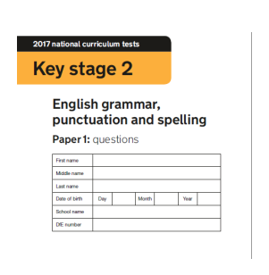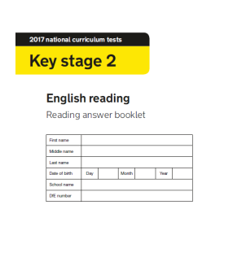

There is no **writing test** - this is assessed by the teacher.

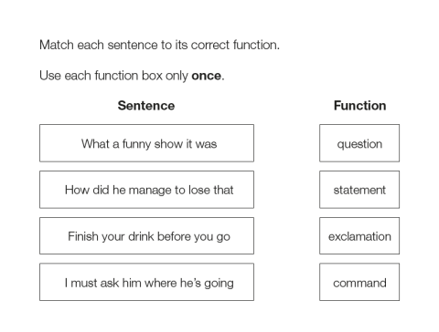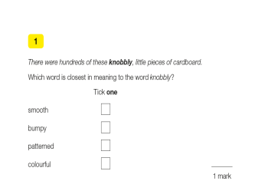

**The Arithmetic Test**

35 questions

No context to the questions, so there is no reading needed

Some can be solved mentally, others require jottings or written methods

Long multiplication and long division are worth 2 marks (all other questions are worth 1 mark)

**What is involved in the Maths tests?**

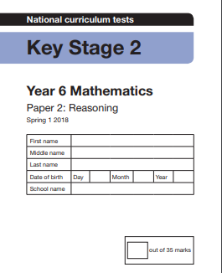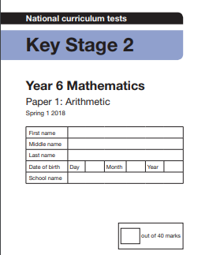

**The Reasoning Tests**

35 marks per paper

They assess mathematical problem solving and reasoning

Calculators not allowed

A significant amount of reading needed

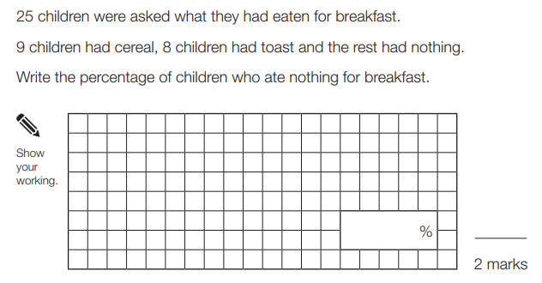

5.6 x 100 =

|  |  |  |
| --- | --- | --- |
|  | Raw score for expected standard | Raw score for higher standard |
| Reading | 28 | 41 |
| GPS | 36 | 55 |
| Maths | 58 | 95 |

You will receive the tests scores before the end of the school year.

**When do we receive the results?**

Once the tests have been externally marked, the school will receive the results. Your child will be allocated a **raw score** (the number of marks they achieved in the test) and a **scaled score**. A scaled score of 100 represents the **expected standard** of the test. The range of scaled scores available are 80 (the lowest scaled score) and 120 (the highest scaled score). To recognise higher attainment in the KS2 tests, a **higher standard** grade may be awarded. The table below shows the raw scores needed to reach both standards in 2019. However,please note **the amount of marks needed to meet expected and higher standard changes each year.**

**How are the results reported to parents?**